**Sample Press Release** (this may be duplicated on your organization’s letterhead)

FOR IMMEDIATE RELEASE

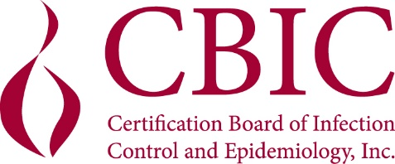

CONTACT: (Insert your organization’s contact)

**(NAME) EARNS CERTIFIED INFECTION CONTROL CREDENTIAL**

Arlington, VA [Date] – CBIC has announced that (NAME), (TITLE) of (ORGANIZATION) has earned the Certified in Infection Control (CIC®) credential and has demonstrated a mastery of infection prevention and control knowledge by taking and passing this comprehensive examination. Certification is maintained through successful completion of examination or continuing education units every five years.

The Certification Board of Infection Control and Epidemiology, Inc. (CBIC®) administers the exam certifying individuals as CICs. The purpose of the certification process is to protect the public by providing standardized measurement of current basic knowledge needed for persons practicing infection control; encouraging individual growth and study, thereby promoting professionalism among infection prevention and control professionals; and formally recognizing infection prevention and control professionals who fulfill the guidelines for certification. Individuals who earn their CIC® credential join over 9,600 practitioners worldwide who are Certified in Infection Control. The National Commission for Certifying Agencies (NCCA) accredits CBIC’s certification program, which signifies that CBIC has met the highest national voluntary standards for private certification. CBIC periodically conducts job analyses to assure that certification measures current practices and knowledge required for infection prevention and control and applied epidemiology.

CBIC is a voluntary autonomous multidisciplinary board that provides direction for and administers the certification process for professionals in infection prevention and control and applied epidemiology. CBIC is independent and separate from any other infection control-related organization or association. In 2023, CBIC celebrated 40 years of protecting the public through the development, administration, and promotion of an accredited certification in infection prevention and control. For more information about CBIC, visit www.cbic.org.

###